**Задачи по WEB дизайн – упражнение 2**

**Задача 1**

Създайте файлове с наименования index.html и styles.css. Свържете CSS файла към HTML документа.

В HTML документа, използвайки подходящи тагове, създайте следното съдържание (текстът е приложен в края на документа).

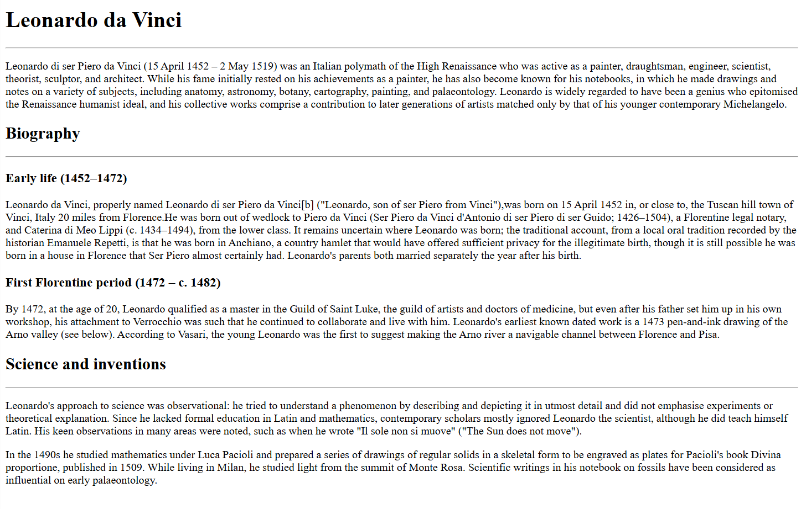

Приложете следното стилизиране (можете да модифицирате подадените цветове по избор):

1. Задайте на тялото на документа (body) фон beige, цвят на текста: chocolate.
2. Селектирайте заглавието от първо ниво (Leonardo da Vinci) и му задайте цвят на текста brown. Текстът да е удебелен. Размер на шрифта – 24px.
3. Заглавието от второ ниво да е удебелено и центрирано. Размер на шрифта – 22px.
4. Заглавието от трето ниво да е удебелено и в курсив. Размер на шрифта – 20px.
5. Параграфите в текста да са двустранно подравнени, 16px.
6. Създайте клас text-center, като му зададете свойство текстът, на който е приложен, да е центриран. Приложете на заглавията от първо ниво и трето ниво.
7. Създайте клас text-left, като му зададете свойство текстът, на който е приложен, да е подравнен вляво. Приложете на заглавията от второ ниво. Какво ще бъде подравняването на заглавието след добавянето на класа – центрирано или вляво? Проверете във VS Code специфичността на двата селектора.
8. Създайте клас highlight, като зададете цвят на фона gold и цвят на текста darkgreen. Приложете го на първия параграф и на секцията, формирана от второто заглавие от трето ниво и текстът под нея.
9. Оградете текста „Leonardo di ser Piero da Vinci ("Leonardo, son of ser Piero from Vinci")” с инлайн контейнер (span), на който задайте уникален идентификатор “person-name”. Селектирайте по id и задайте удебеляване и цвят на текста crimson.
10. Селектирайте само хоризонталните линии, които са след заглавията от второ ниво. Задайте им височина 2px (height: 2px;) и цвят на фона crimson. Каква е специфичността на използвания селектор?

Резултат:

**Задача 2**

Създайте файлове с наименования index.html и styles.css. Свържете CSS файла към HTML документа.

Създайте и стилизирайте документа, чийто изглед е поместено по-долу (текстът е приложен в края на документа). Можете за избирате между различни селектори, но нека да има поне един селектор по таг, поне един по клас и поне един по id. Цветовите комбинации оставям на Вас.

Текст към задача 1

Leonardo da Vinci

Leonardo di ser Piero da Vinci (15 April 1452 – 2 May 1519) was an Italian polymath of the High Renaissance who was active as a painter, draughtsman, engineer, scientist, theorist, sculptor, and architect. While his fame initially rested on his achievements as a painter, he has also become known for his notebooks, in which he made drawings and notes on a variety of subjects, including anatomy, astronomy, botany, cartography, painting, and palaeontology. Leonardo is widely regarded to have been a genius who epitomised the Renaissance humanist ideal, and his collective works comprise a contribution to later generations of artists matched only by that of his younger contemporary Michelangelo.

Biography

Early life (1452–1472)

Leonardo da Vinci, properly named Leonardo di ser Piero da Vinci ("Leonardo, son of ser Piero from Vinci"), was born on 15 April 1452 in, or close to, the Tuscan hill town of Vinci, Italy 20 miles from Florence. He was born out of wedlock to Piero da Vinci (Ser Piero da Vinci d'Antonio di ser Piero di ser Guido; 1426–1504), a Florentine legal notary, and Caterina di Meo Lippi (c. 1434–1494), from the lower class. It remains uncertain where Leonardo was born; the traditional account, from a local oral tradition recorded by the historian Emanuele Repetti, is that he was born in Anchiano, a country hamlet that would have offered sufficient privacy for the illegitimate birth, though it is still possible he was born in a house in Florence that Ser Piero almost certainly had. Leonardo's parents both married separately the year after his birth.

First Florentine period (1472 – c. 1482)

By 1472, at the age of 20, Leonardo qualified as a master in the Guild of Saint Luke, the guild of artists and doctors of medicine, but even after his father set him up in his own workshop, his attachment to Verrocchio was such that he continued to collaborate and live with him. Leonardo's earliest known dated work is a 1473 pen-and-ink drawing of the Arno valley (see below). According to Vasari, the young Leonardo was the first to suggest making the Arno river a navigable channel between Florence and Pisa.

Science and inventions

Leonardo's approach to science was observational: he tried to understand a phenomenon by describing and depicting it in utmost detail and did not emphasise experiments or theoretical explanation. Since he lacked formal education in Latin and mathematics, contemporary scholars mostly ignored Leonardo the scientist, although he did teach himself Latin. His keen observations in many areas were noted, such as when he wrote "Il sole non si muove" ("The Sun does not move").

In the 1490s he studied mathematics under Luca Pacioli and prepared a series of drawings of regular solids in a skeletal form to be engraved as plates for Pacioli's book Divina proportione, published in 1509. While living in Milan, he studied light from the summit of Monte Rosa. Scientific writings in his notebook on fossils have been considered as influential on early palaeontology.

Текст към задача 2

Tron

Cast

The list of the main characters is included only.

Jeff Bridges as Kevin Flynn, a former ENCOM programmer and video game developer who runs an arcade following his termination from the company. He is beamed into the mainframe via a digitizing laser by the MasterControl Program. Bridges also portrays Clu (Codified Likeness Utility), a hacking program developed by Flynn to find evidence of Dillinger's theft in the mainframe.

Bruce Boxleitner as Alan Bradley, Flynn's work partner and fellow ENCOM programmer. Boxleitner also portrays Tron, a security program developed by Alan to self-monitor communications between the MCP and the real world.

David Warner as Ed Dillinger, the senior executive vice president of ENCOM. He was once a coworker of Flynn who used the Master Control Program to steal the latter's work and pass it off as his own, earning himself a series of undeserved promotions.

Warner also portrays Sark, a command program developed by Dillinger to serve as the MCP's second-in-command. Warner additionally provided the uncredited voice of the Master Control Program (MCP), a rogue artificial intelligence operating system that originated as a chess program created by Dr. Walter Gibbs but annexed by Dillinger for his own use. The MCP monitors and controls ENCOM's mainframe.

Cindy Morgan as Dr. Lora Baines, Alan's coworker and girlfriend. She and Gibbs collaborate on  ENCOM's digitization experiment. Morgan also portrays Yori, an input/output program developed by Lora and an ally of Tron. Barnard Hughes as Dr. Walter Gibbs, a co-founder of ENCOM who runs the company's science division. He creates the SHV 20905 digitizing laser with Lora's assistance.

Hughes also plays Dumont, a guardian program developed by Gibbs to protect input/output junctions in the mainframe. Hughes was also the MCP's physical form, which was shown just before it died.

Dan Shor as Ram, an actuarial program who is a close ally of Tron and Flynn. Shor also briefly appears as an ENCOM programmer credited as "Popcorn Co-Worker".

Peter Jurasik as Crom, a compound interest program matched against Flynn on the Game Grid.

Tony Stephano as Peter, Dillinger's assistant. Stephano additionally played Sark's Lieutenant.

Soundtrack

The soundtrack hit all the charts in USA and Europe.

The soundtrack for Tron was written by pioneer electronic musician Wendy Carlos, who is best known for her album Switched-On Bach and for the soundtracks to many films, including the Stanley Kubrick-directed films A Clockwork Orange and The Shining. The music, which was the first collaboration between Carlos and her partner Annemarie Franklin, featured a mix of an analog Moog synthesizer and Crumar's GDS digital synthesizer (complex additive

and phase modulation synthesis), along with non-electronic pieces performed by the London Philharmonic Orchestra (hired at the insistence of Disney, which was concerned that Carlos might not be able to complete her score on time).

Two additional musical tracks ("1990's Theme" and "Only Solutions") were provided by the American band Journey after British band Supertramp pulled out of the project. An album featuring dialogue, music and  sound effects from the film was also released on LP by Disneyland Records in 1982.